Exercise sec19

Mehrab Atighi

12/3/2021

library(MASS)  
data = read.table("F:/lessons/Multi countios Variate2/data/apple-data.txt",header = TRUE)  
head(data,4)

## group y1 y2 y3 y4  
## 1 1 1.11 2.569 3.58 0.760  
## 2 1 1.19 2.928 3.75 0.821  
## 3 1 1.09 2.865 3.93 0.928  
## 4 1 1.25 3.844 3.94 1.009

tail(data,4)

## group y1 y2 y3 y4  
## 45 6 1.05 1.949 3.34 0.610  
## 46 6 1.07 2.251 3.21 0.562  
## 47 6 1.13 3.064 3.63 0.707  
## 48 6 1.11 2.469 3.95 0.952

plot(data[,-1])

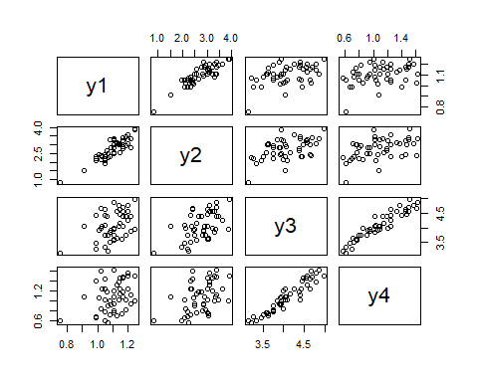

model = qda(data$group~. , data = data)  
model

## Call:  
## qda(data$group ~ ., data = data)  
##   
## Prior probabilities of groups:  
## 1 2 3 4 5 6   
## 0.1666667 0.1666667 0.1666667 0.1666667 0.1666667 0.1666667   
##   
## Group means:  
## y1 y2 y3 y4  
## 1 1.13750 2.977125 3.73875 0.871125  
## 2 1.15750 3.109125 4.51500 1.280500  
## 3 1.10750 2.815250 4.45500 1.391375  
## 4 1.09750 2.879750 3.90625 1.039000  
## 5 1.08000 2.557250 4.31250 1.181000  
## 6 1.03625 2.214625 3.59625 0.735000

pp = predict(model)  
(t=table(pp$class,data$group))

##   
## 1 2 3 4 5 6  
## 1 8 0 1 0 0 2  
## 2 0 7 0 0 3 0  
## 3 0 0 6 1 0 0  
## 4 0 1 0 7 0 0  
## 5 0 0 1 0 4 1  
## 6 0 0 0 0 1 5

(accuracy = sum(diag(t)) / length(data$group))

## [1] 0.7708333

(miss_err_classification_rate = 1 - accuracy)

## [1] 0.2291667